第四讲 随机变量的数字特征

知识点：

常见分布的期望、方差：
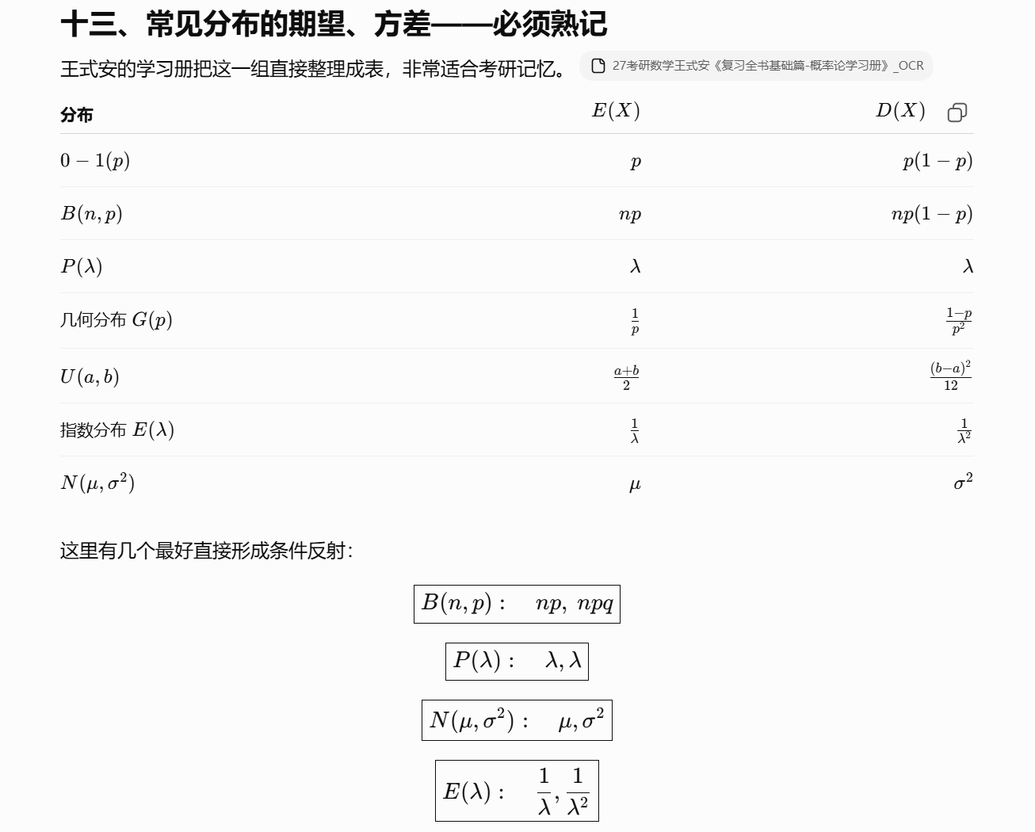
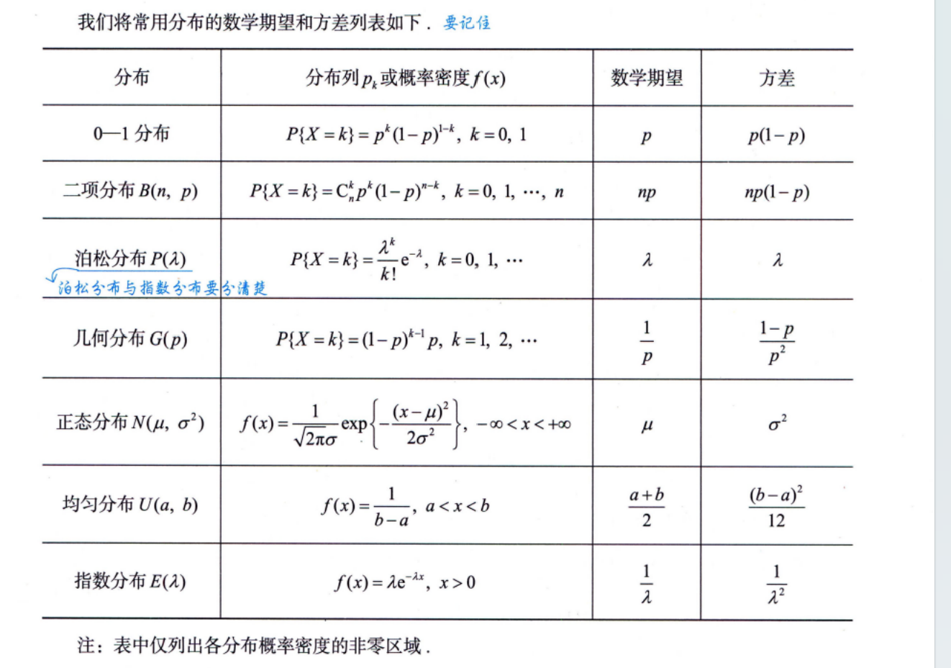
https://chatgpt.com/c/6a7e9987-f920-83ee-a8d8-9e9a65039dda

期望：
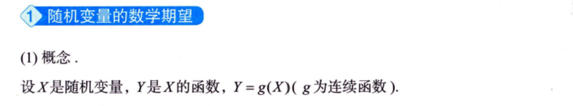
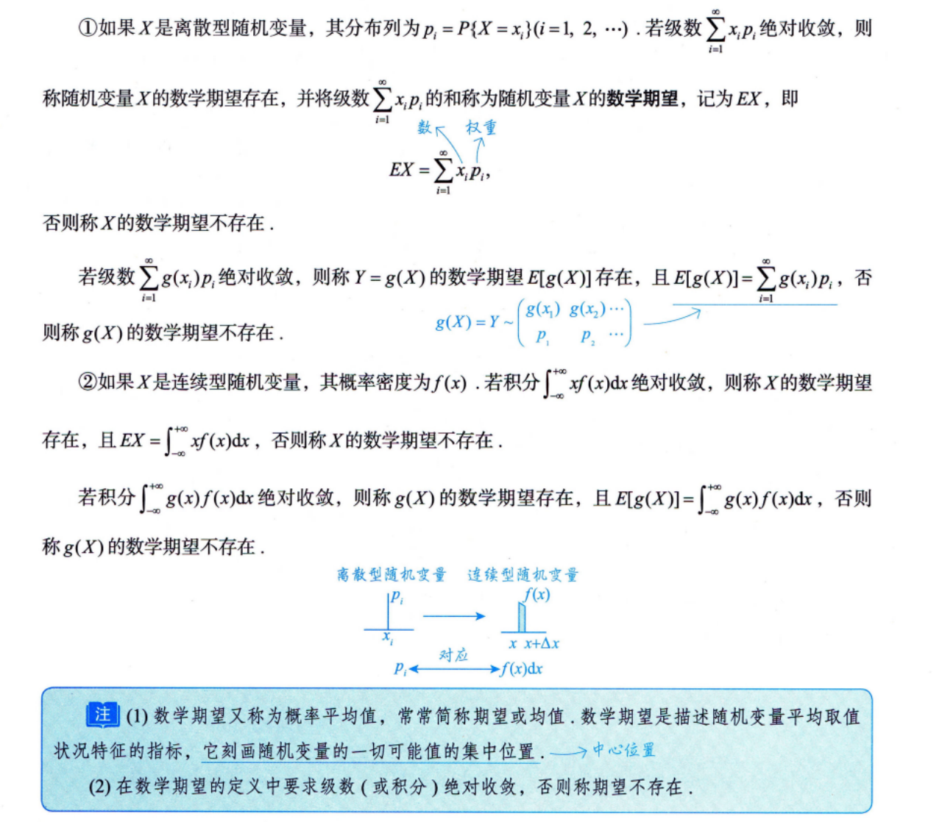
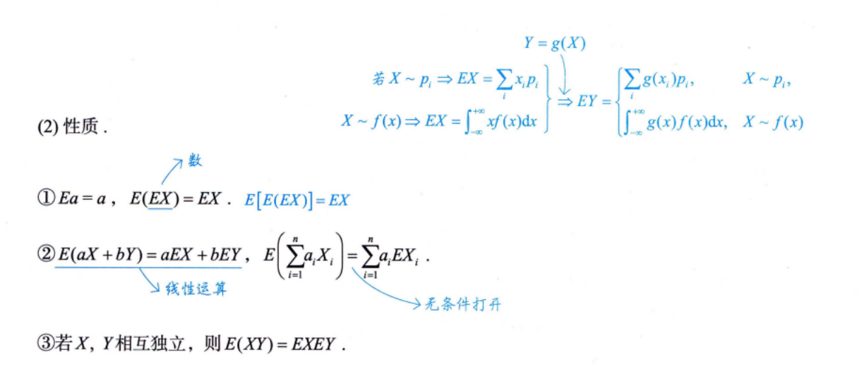

方差：
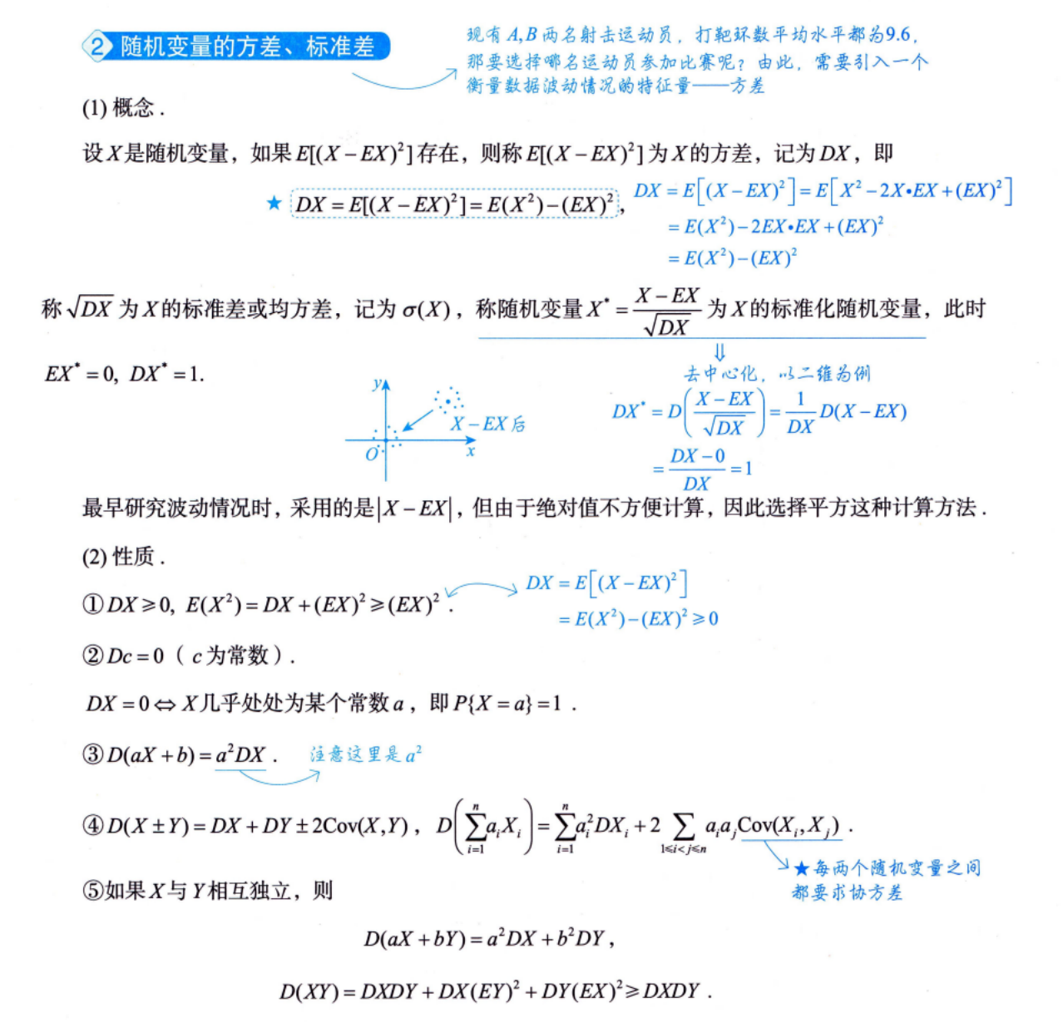
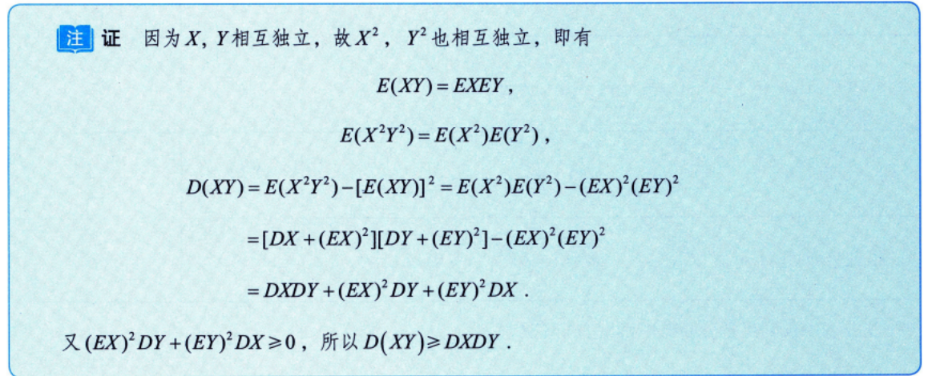
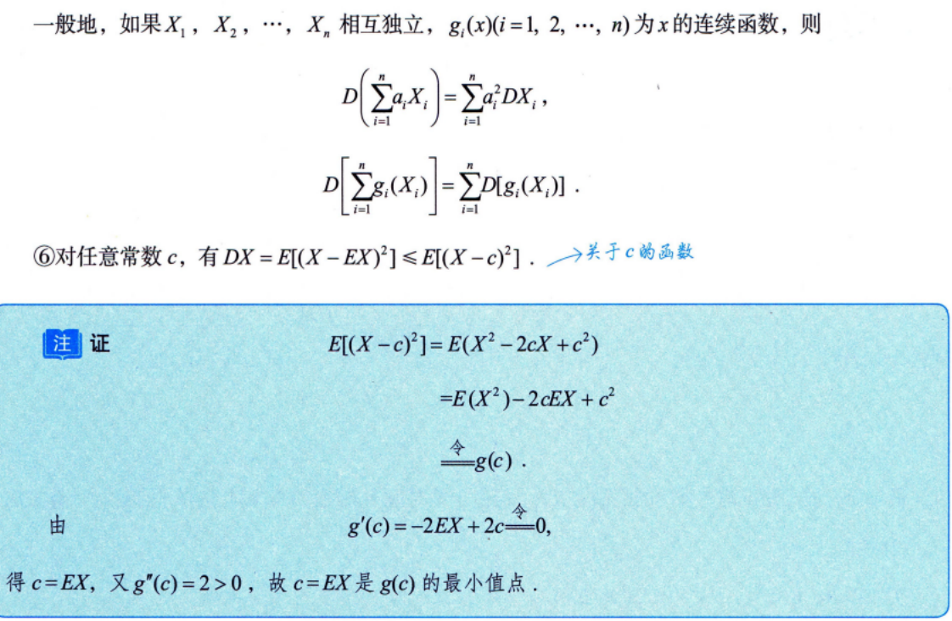

协方差：
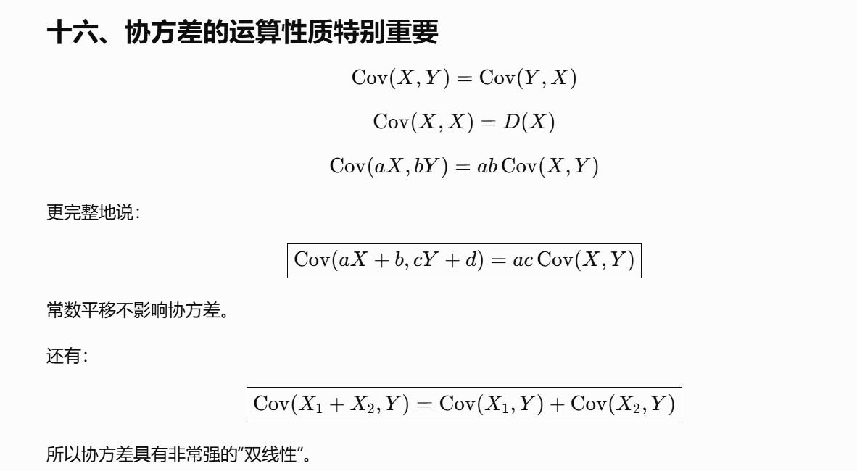

相关系数：
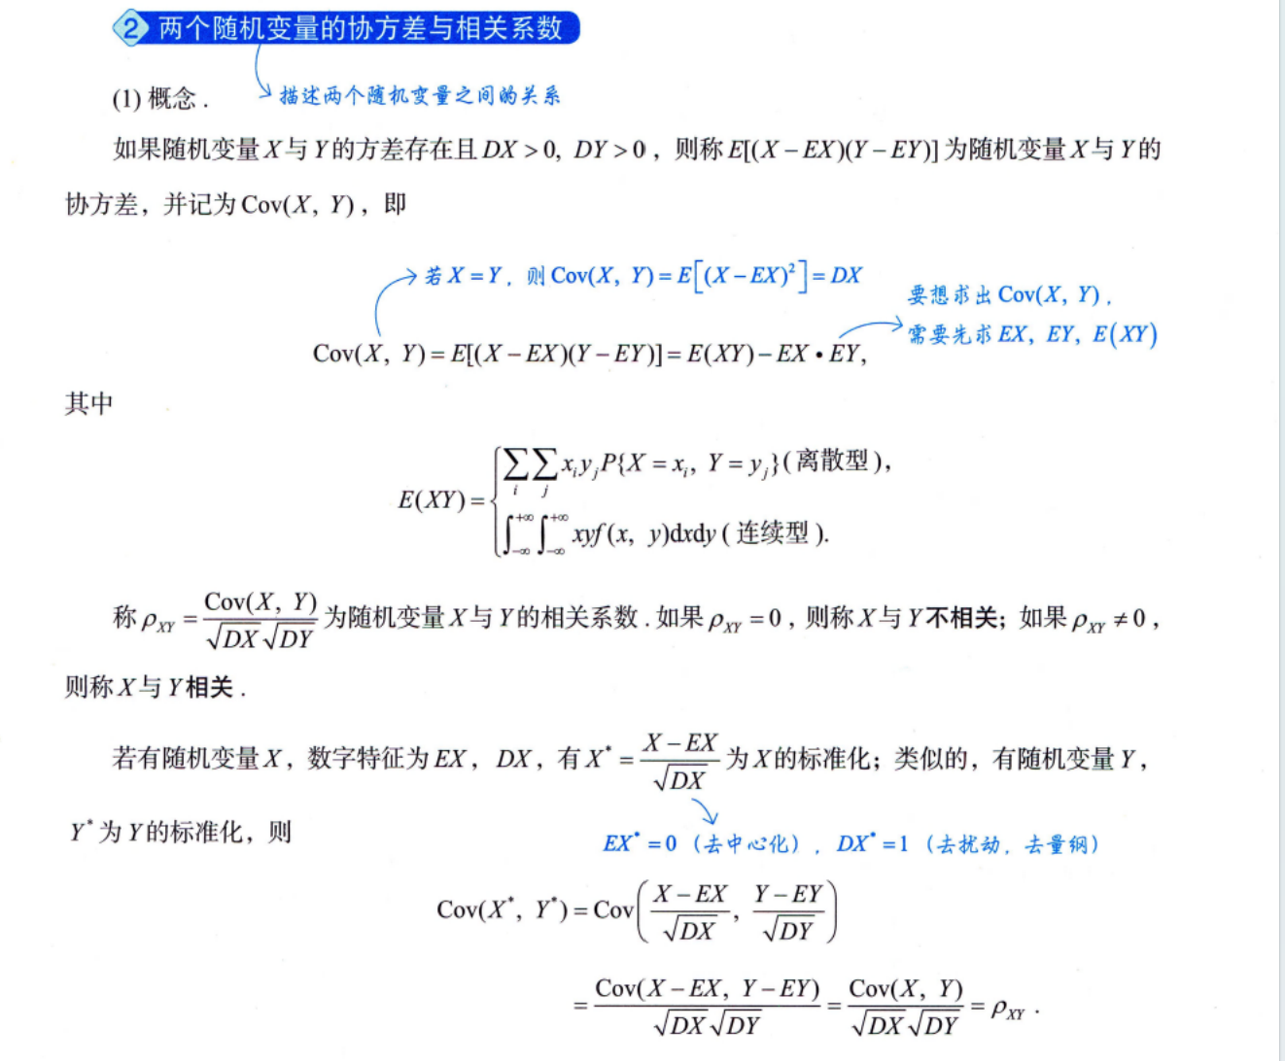

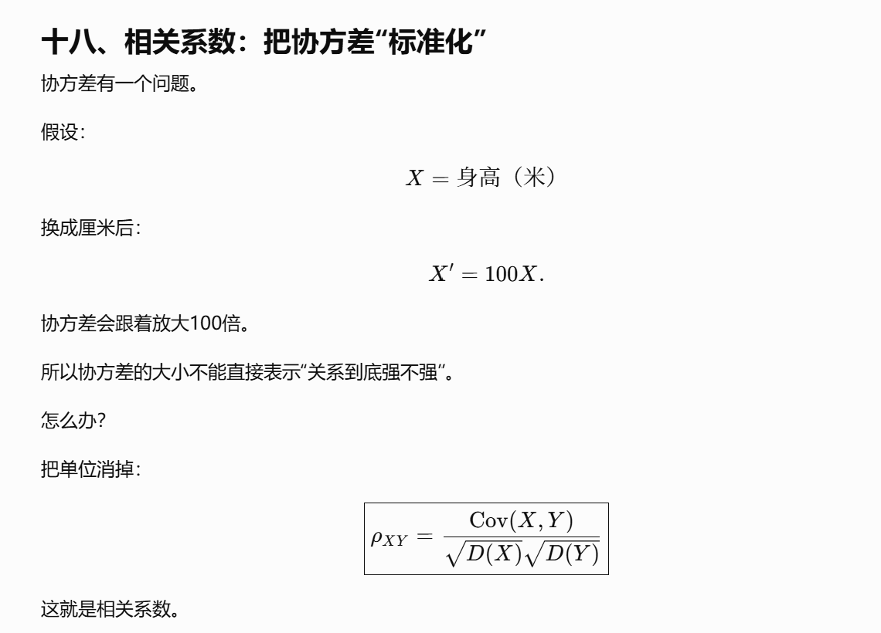
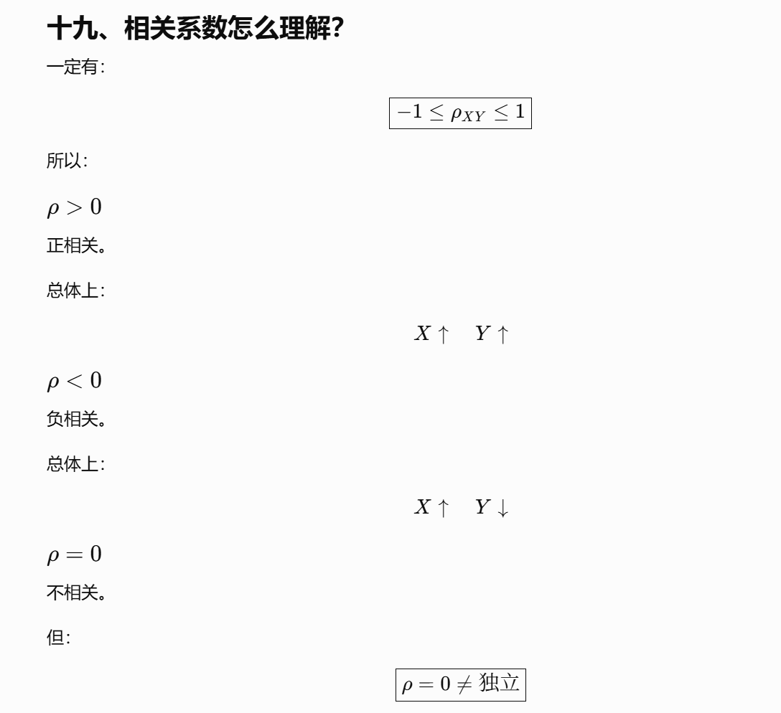
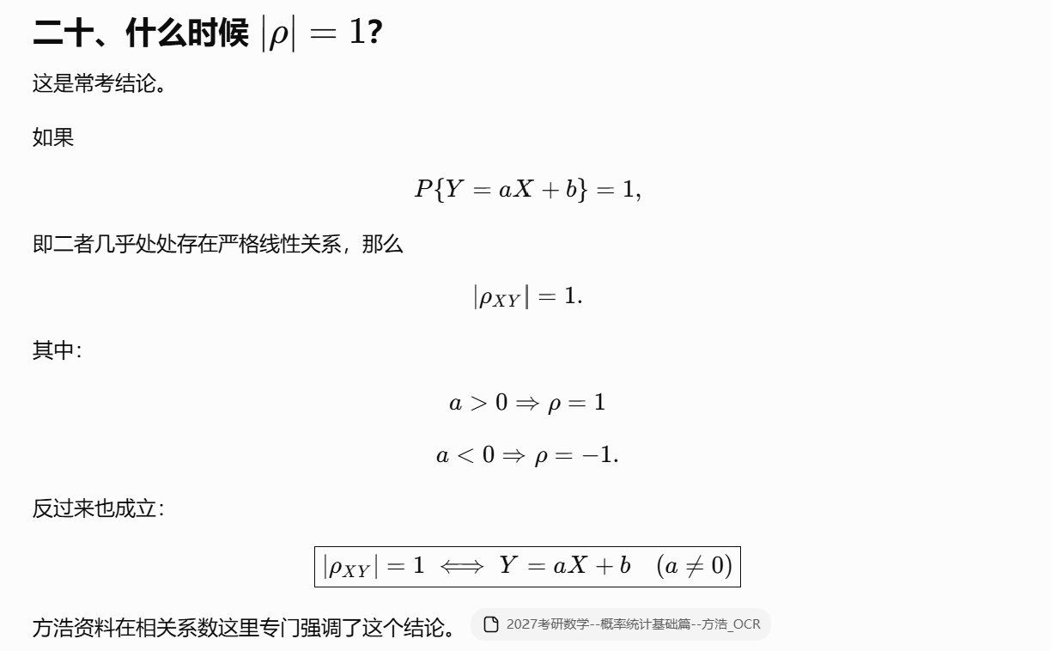
独立：
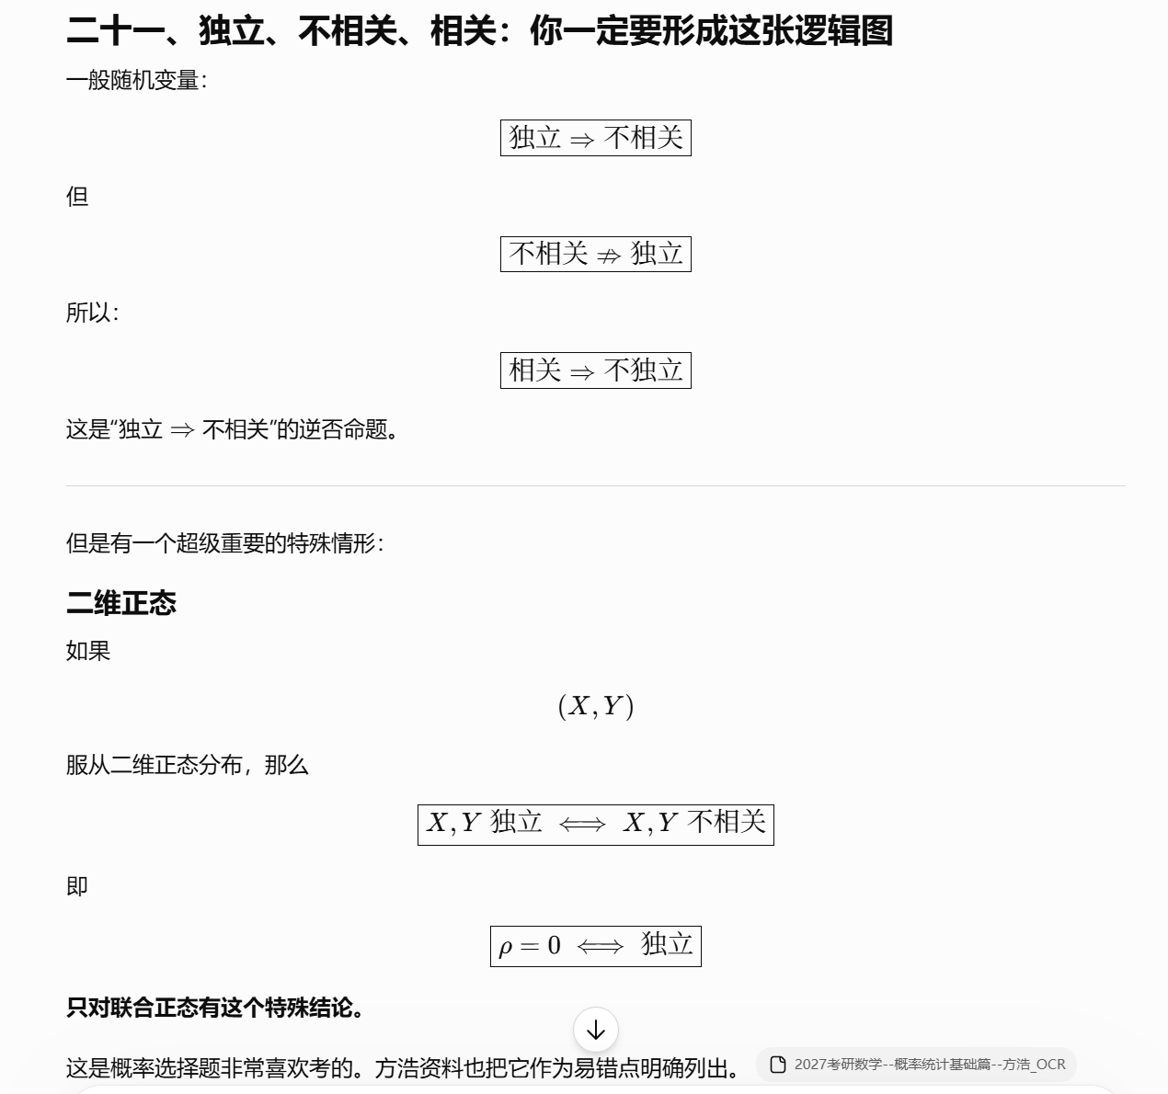

二维随机变量函数的期望：
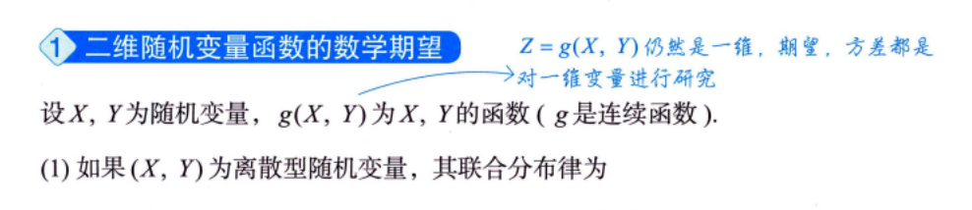
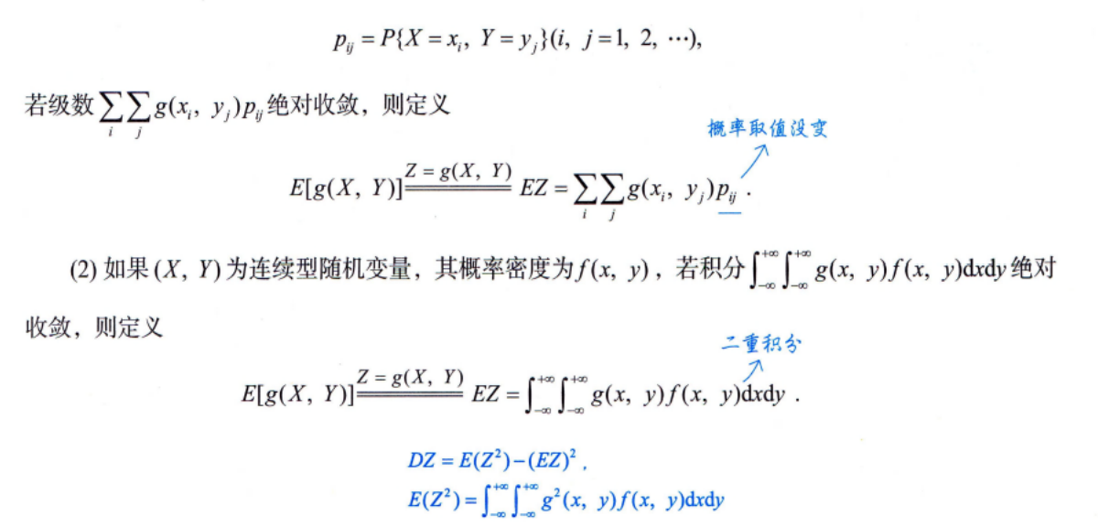
https://chatgpt.com/g/g-p-6a1d6c6f0a408191a175c887909fceb5-xian-dai-he-gai-lu-lun-ocr/c/6a7eb8c8-2884-83e8-83e5-c7e18702e8fc

二维随机变量协方差与相关系数：
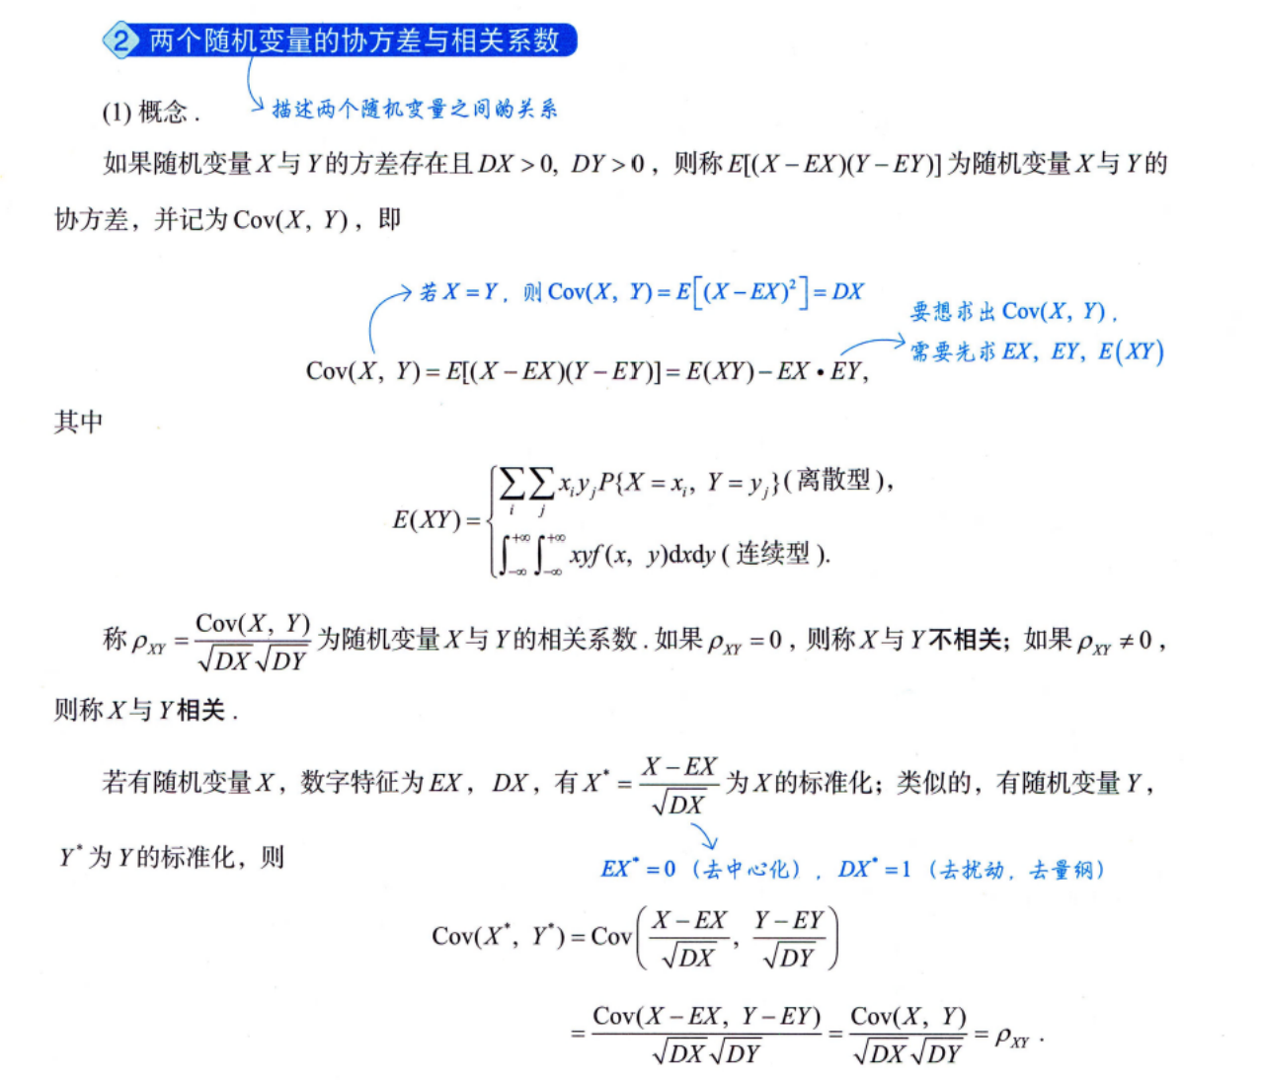
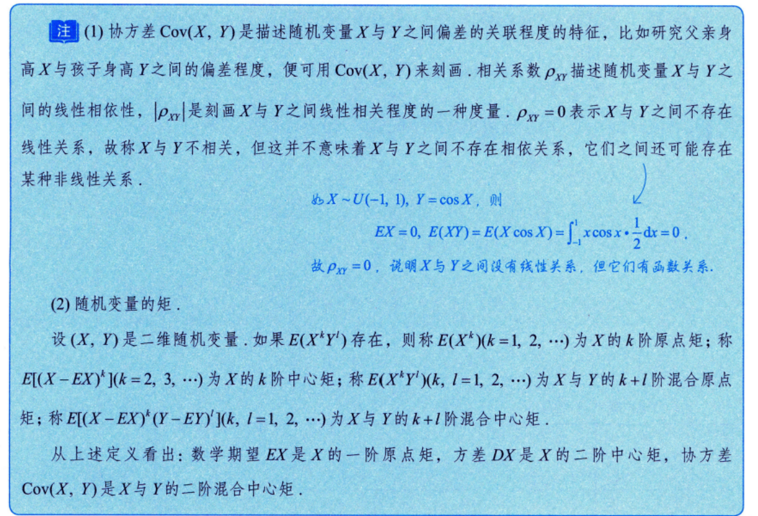
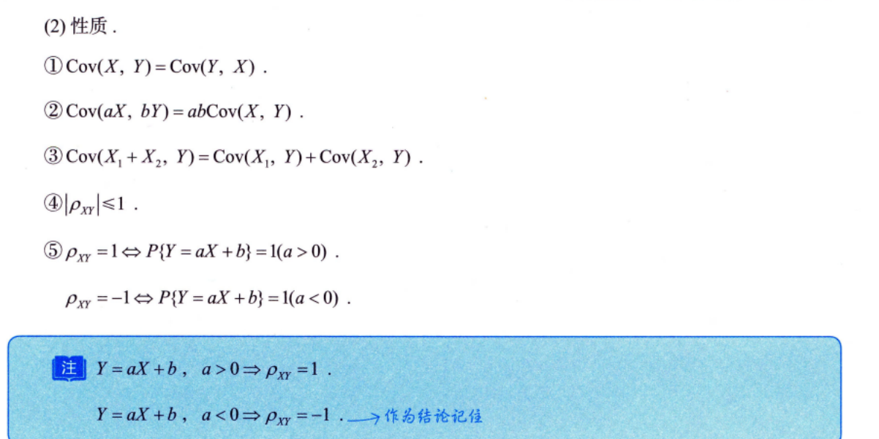
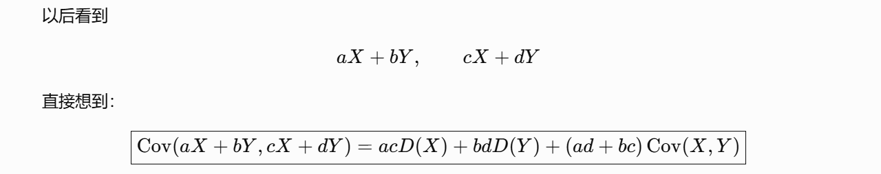
https://chatgpt.com/g/g-p-6a1d6c6f0a408191a175c887909fceb5-xian-dai-he-gai-lu-lun-ocr/c/6a7ebc8d-9530-83e9-82f2-4302b554138b

独立性与不相关性的判定：
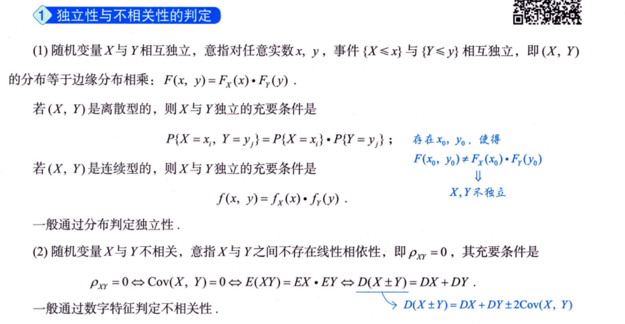
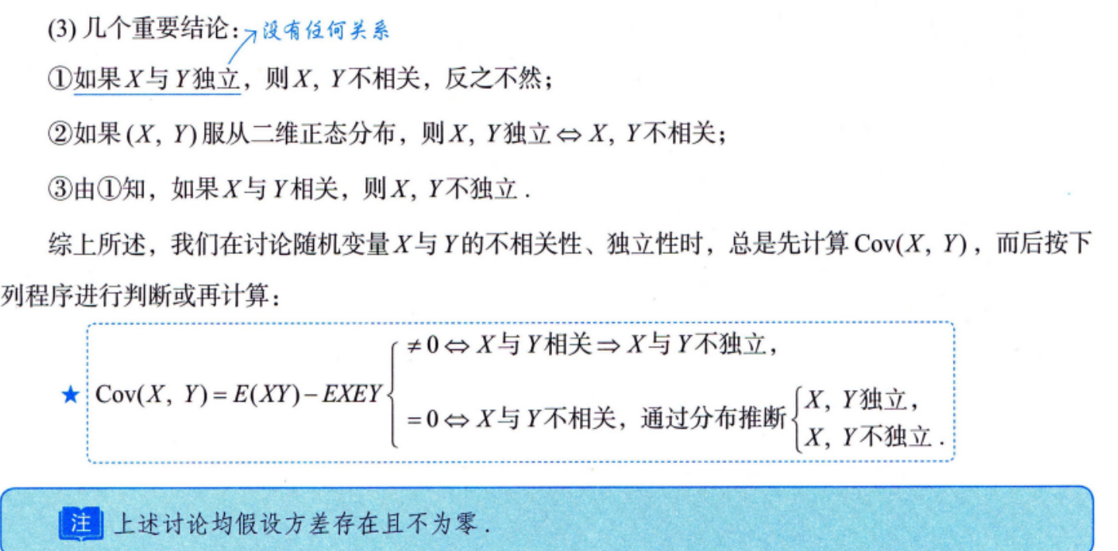

切比雪夫不等式：
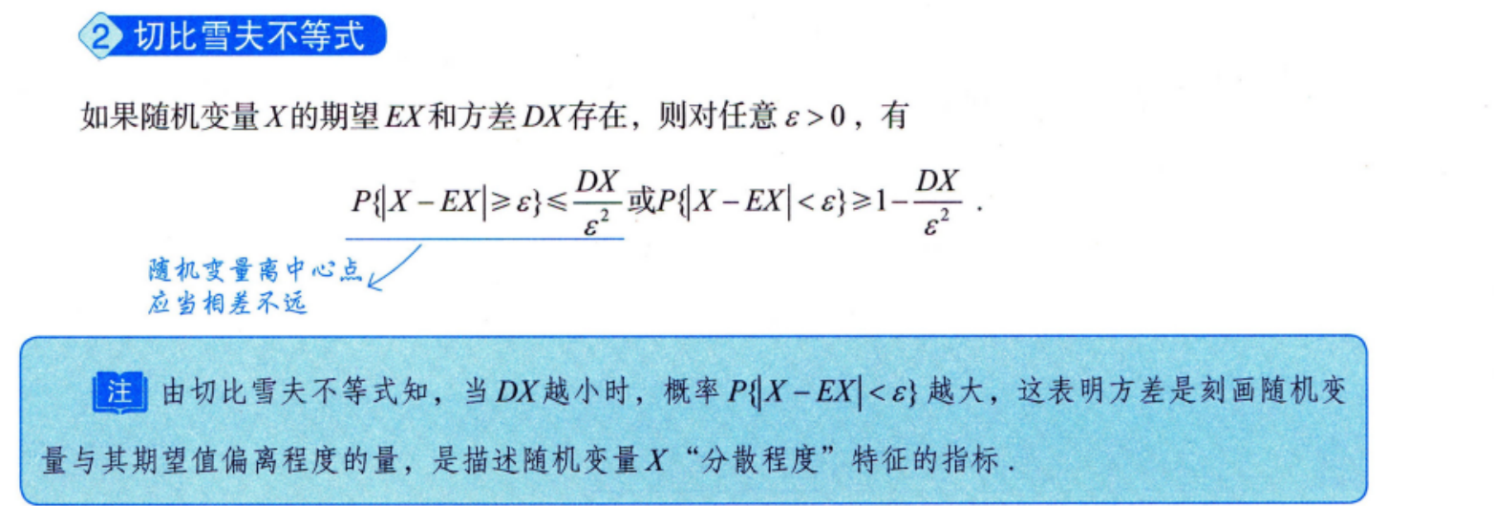
https://chatgpt.com/g/g-p-6a1d6c6f0a408191a175c887909fceb5-xian-dai-he-gai-lu-lun-ocr/c/6a7ecc63-0754-83ee-babc-6b5a681fe558

公式：
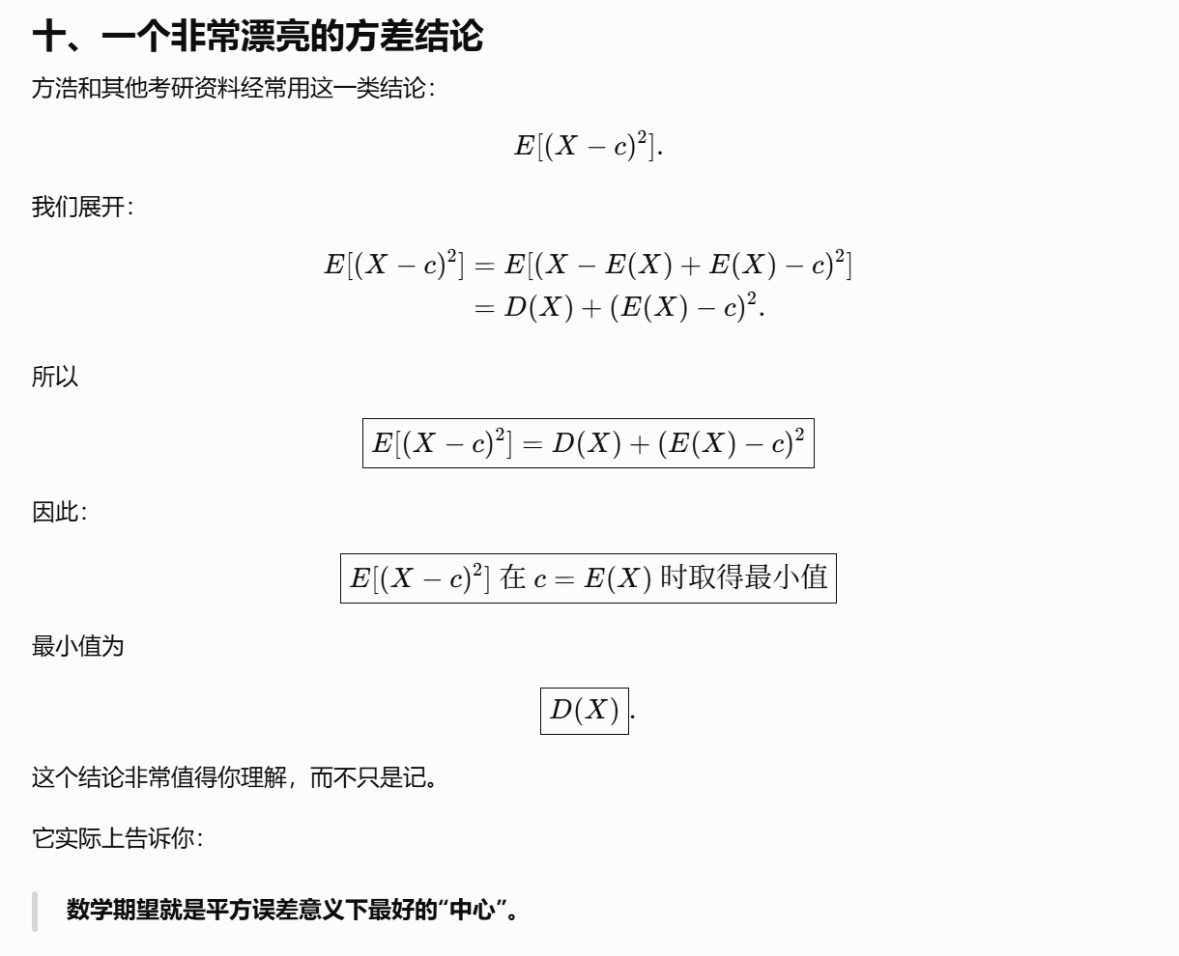

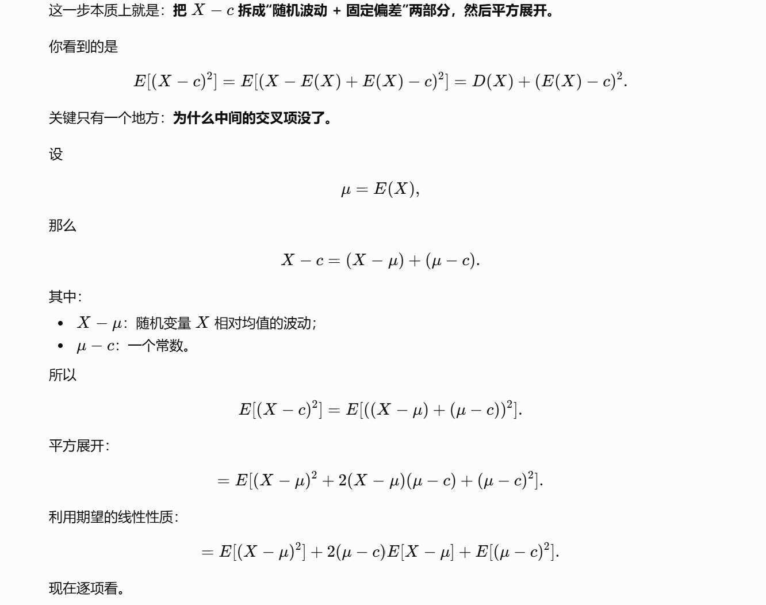
https://chatgpt.com/c/6a771a34-7d74-83e8-ab4d-bead388d8cc4

回顾：

指数分布：
https://chatgpt.com/c/6a7ea4a1-48c0-83ee-b190-e8d374af6ca8

分布函数与概率密度：
https://chatgpt.com/g/g-p-6a1d6c6f0a408191a175c887909fceb5-xian-dai-he-gai-lu-lun-ocr/c/6a7eb200-91fc-83e8-8af5-671bc2478e02

Problems:

含绝对值：
https://chatgpt.com/g/g-p-6a1d6c6f0a408191a175c887909fceb5/c/6a7ead66-6654-83e9-9c7f-bb6827228f41

题：

题1：
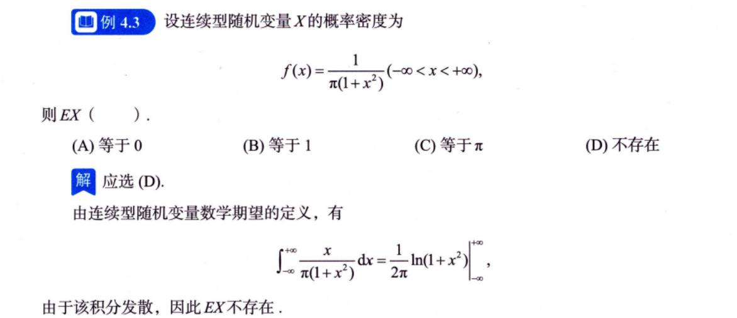
https://chatgpt.com/g/g-p-6a1d6c6f0a408191a175c887909fceb5-xian-dai-he-gai-lu-lun-ocr/c/6a7ea96b-5750-83e8-80b3-c092a39ea48a

题2：
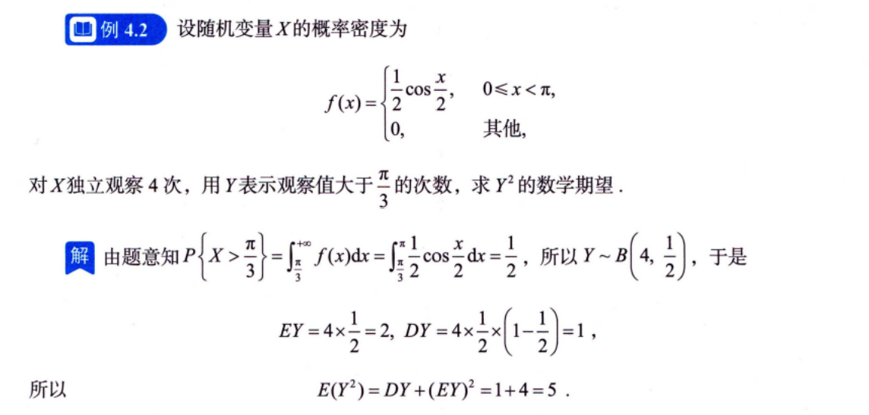
https://chatgpt.com/g/g-p-6a1d6c6f0a408191a175c887909fceb5/c/6a7ea84b-168c-83e9-9364-17fec78a690c

题3：
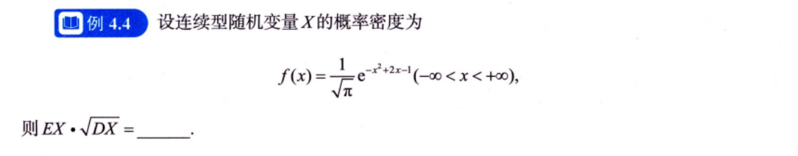
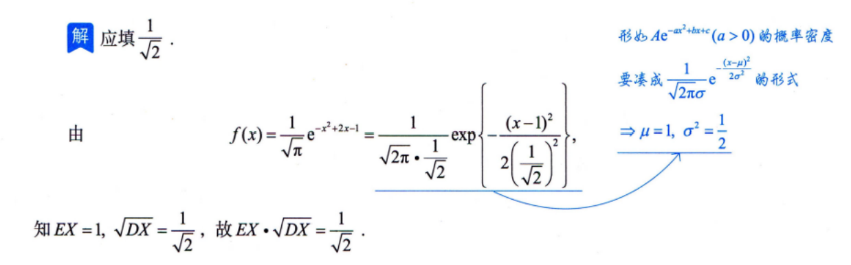

题4：
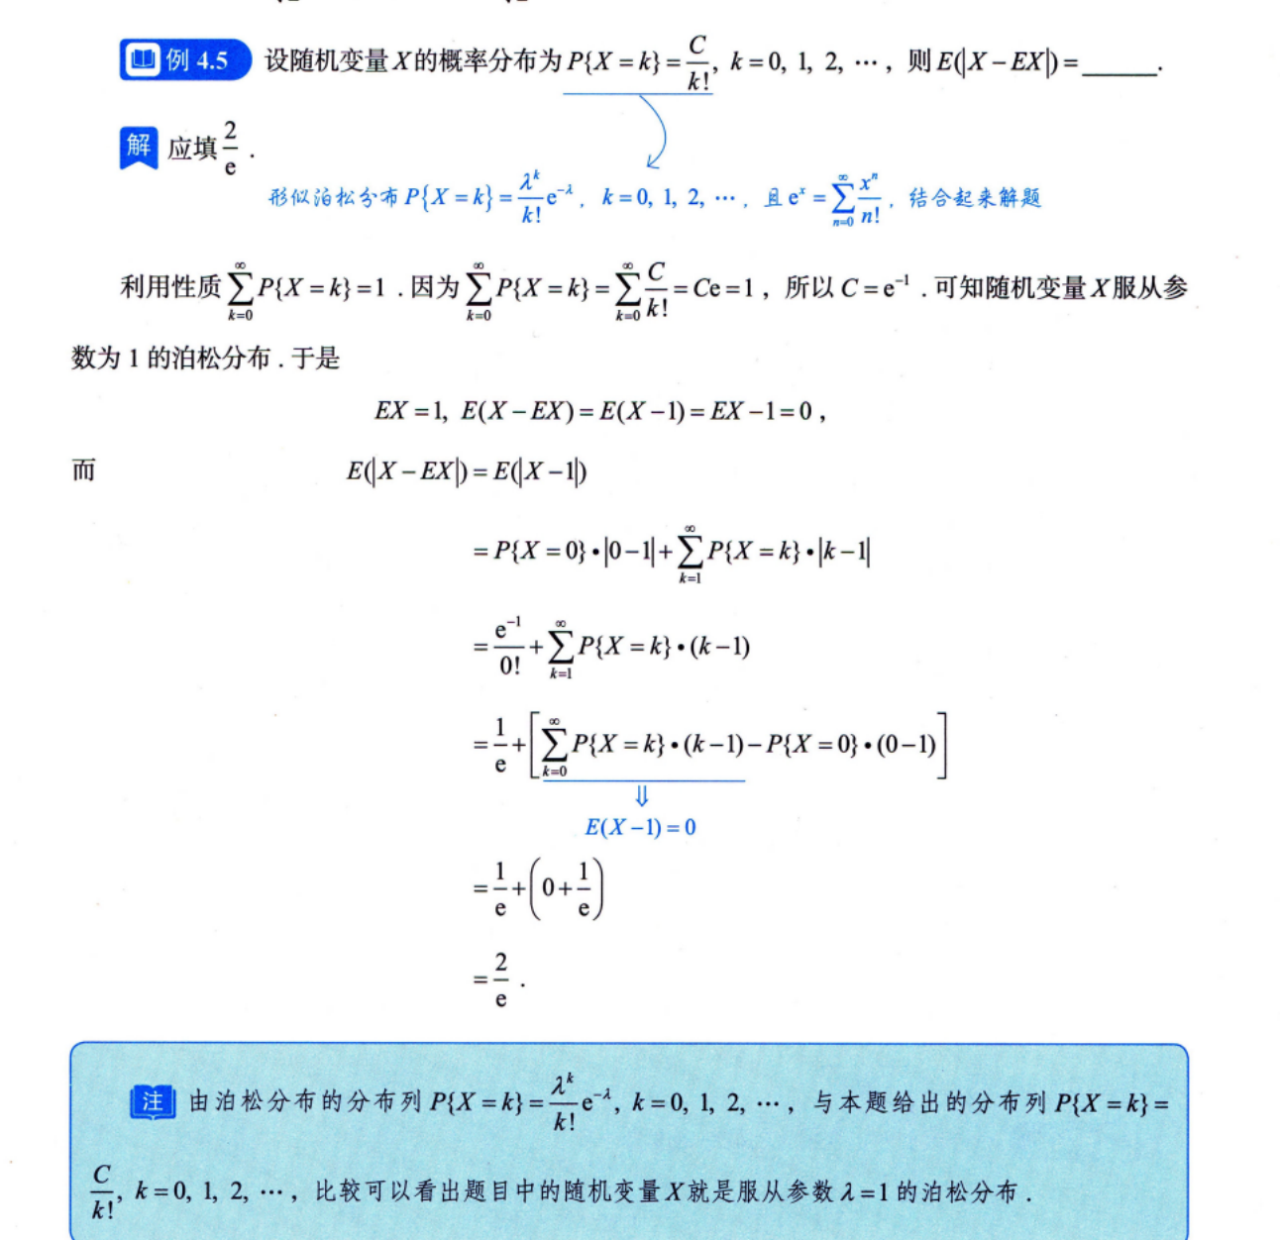
https://chatgpt.com/g/g-p-6a1d6c6f0a408191a175c887909fceb5-xian-dai-he-gai-lu-lun-ocr/c/6a7eaf65-9e64-83e8-97ad-cc8c7b2ee853

题5：
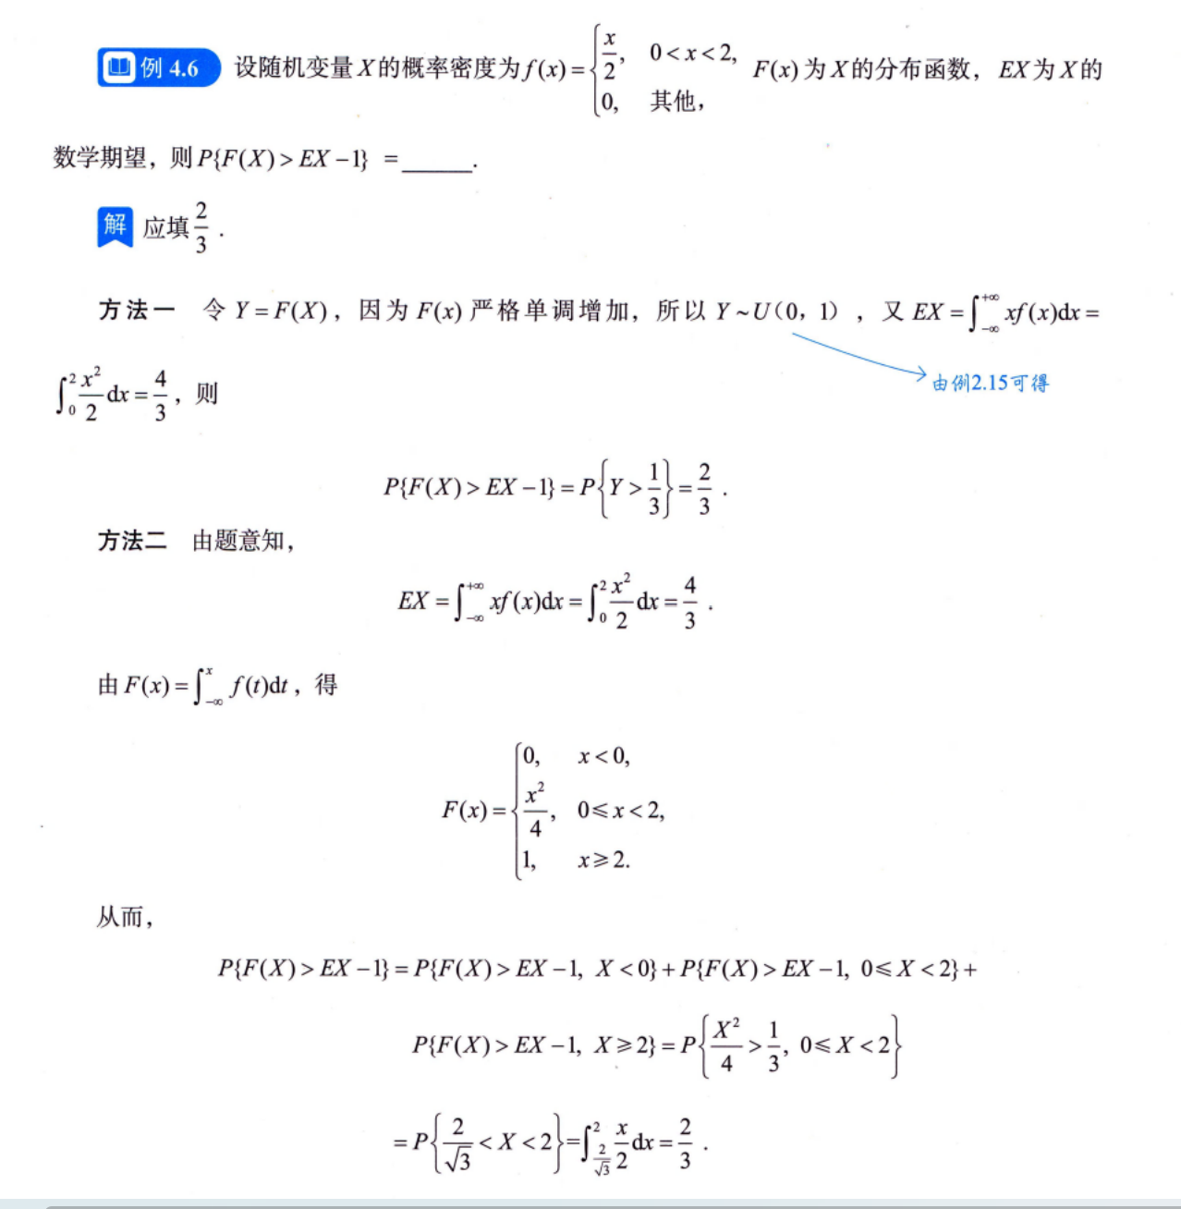
https://chatgpt.com/g/g-p-6a1d6c6f0a408191a175c887909fceb5-xian-dai-he-gai-lu-lun-ocr/c/6a7eb321-4aa8-83ee-92ae-cf9a45f2f30a

题6：
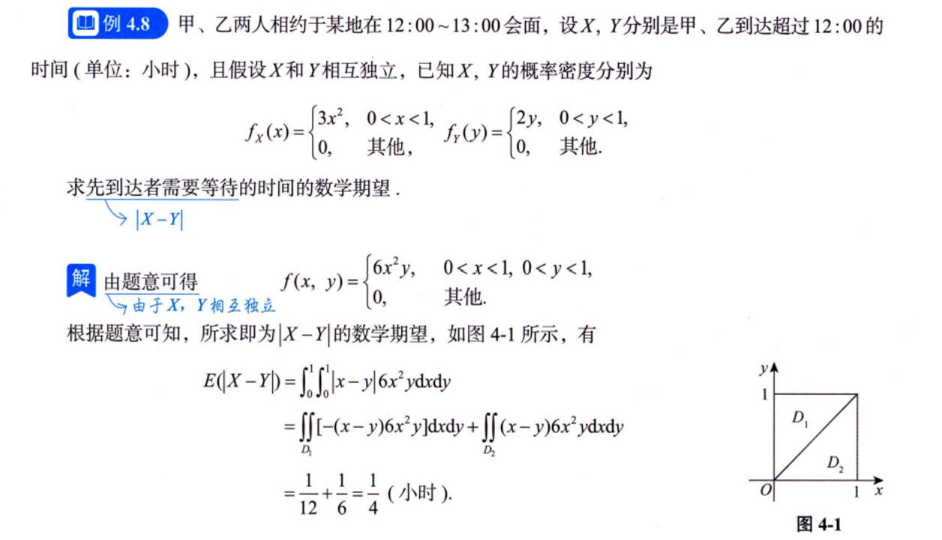

题7：
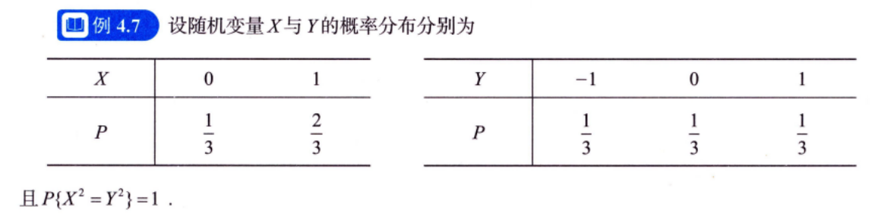
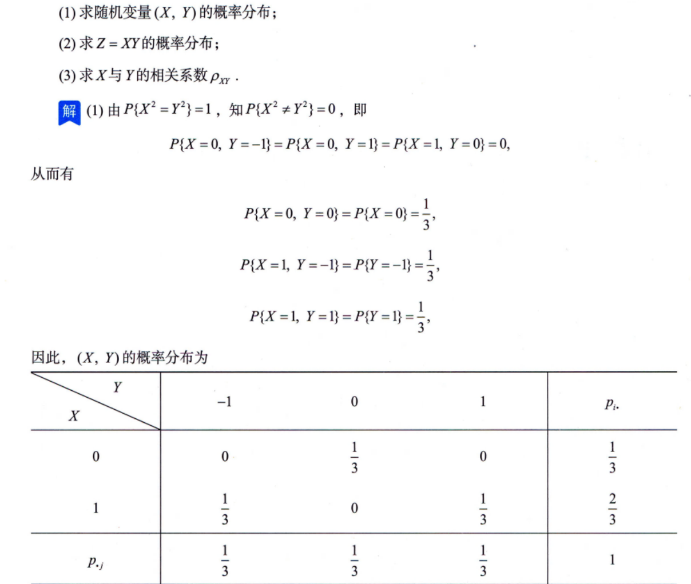
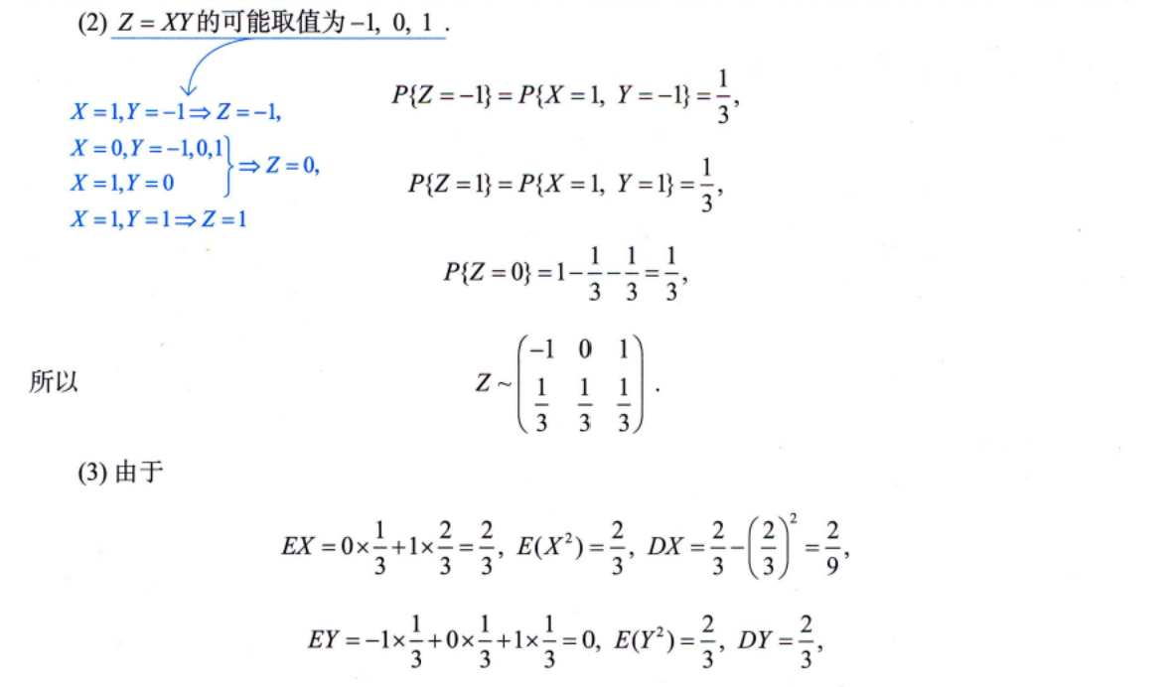

https://chatgpt.com/g/g-p-6a1d6c6f0a408191a175c887909fceb5-xian-dai-he-gai-lu-lun-ocr/c/6a7ec18a-54ec-83e8-9632-fd486b597926

题8：
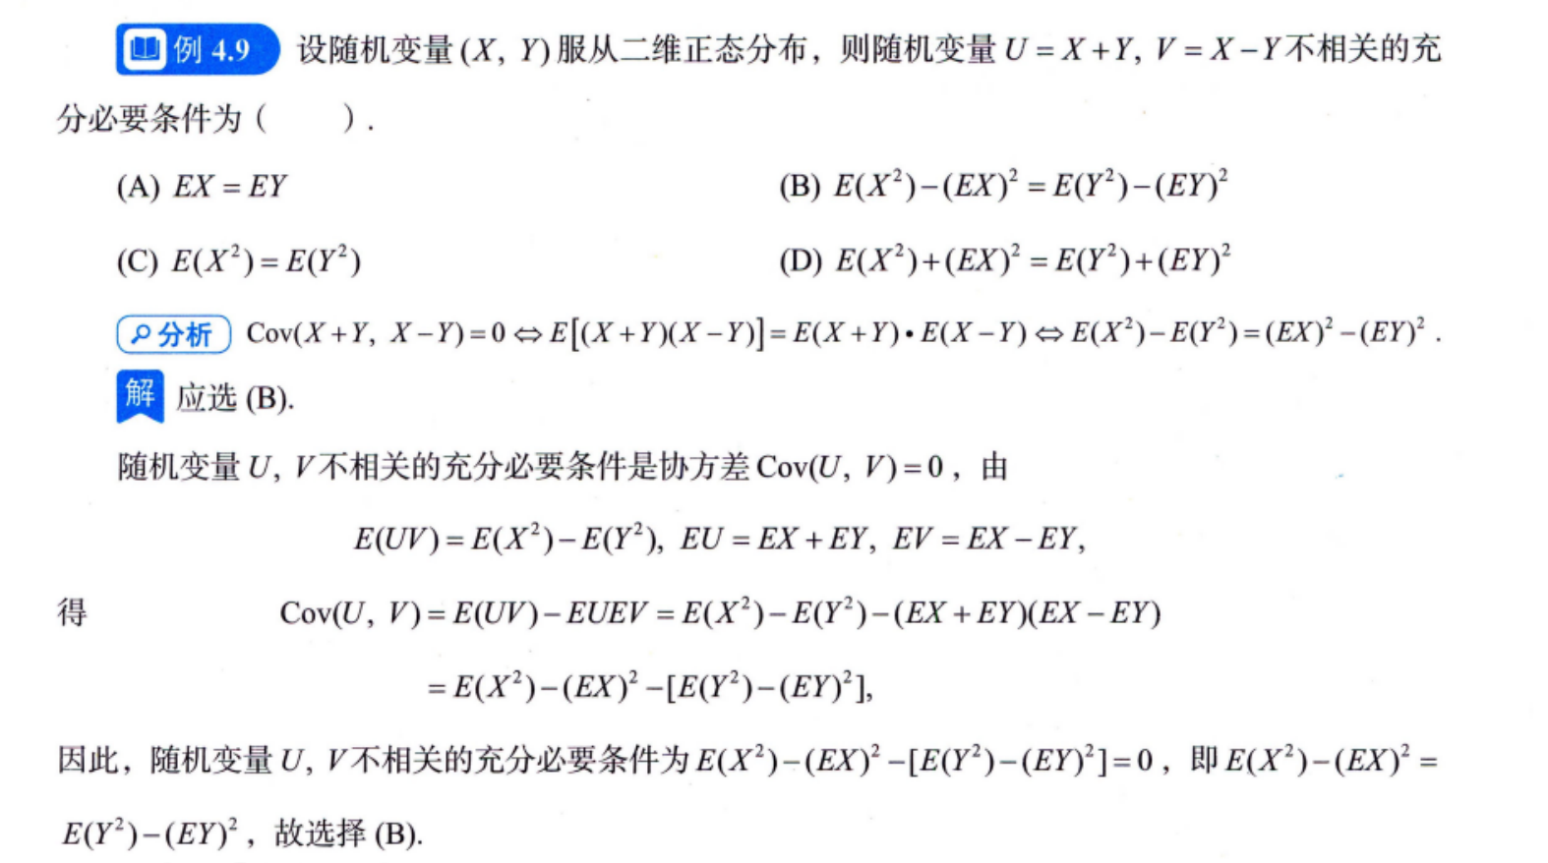
https://chatgpt.com/g/g-p-6a1d6c6f0a408191a175c887909fceb5-xian-dai-he-gai-lu-lun-ocr/c/6a7ed0f7-c10c-83e8-97d9-b840474a953c

题9：
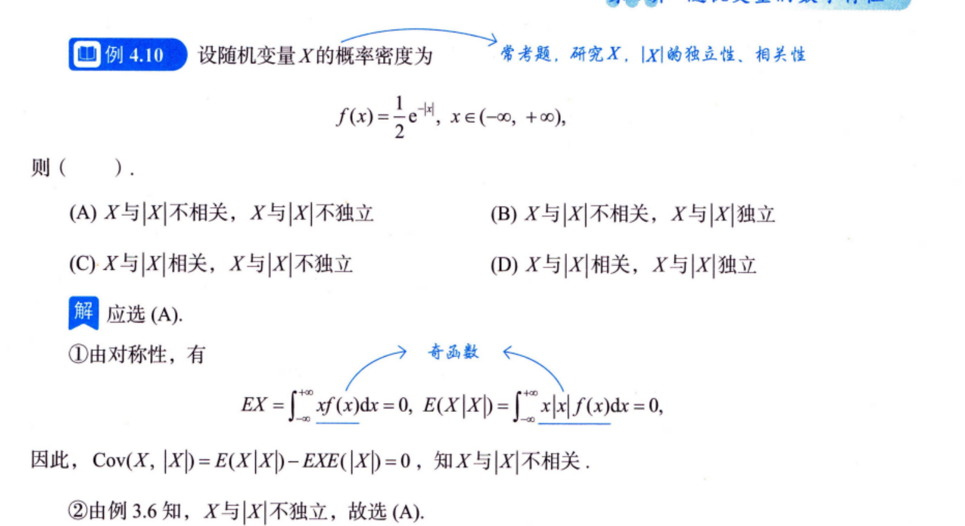
https://chatgpt.com/g/g-p-6a1d6c6f0a408191a175c887909fceb5-xian-dai-he-gai-lu-lun-ocr/c/6a7edea0-3e5c-83e9-9e04-e03fd4632da2

综合题：
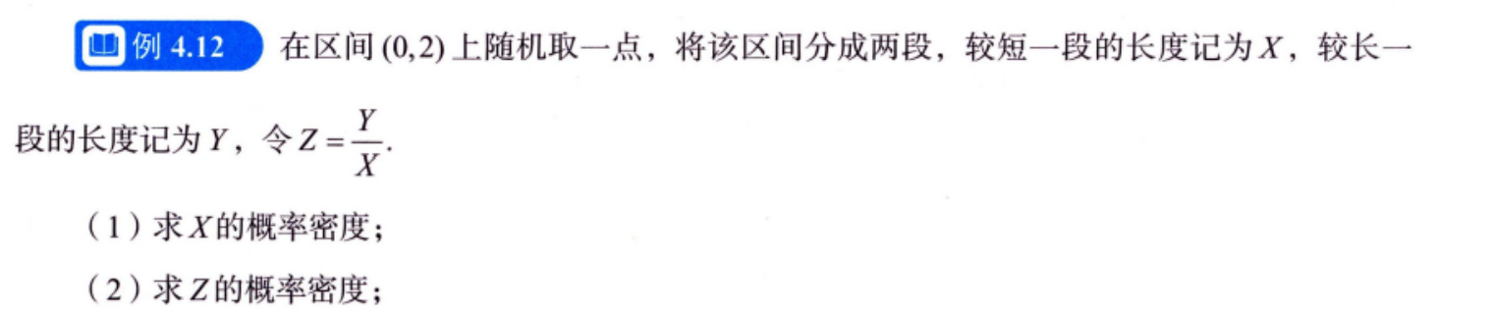
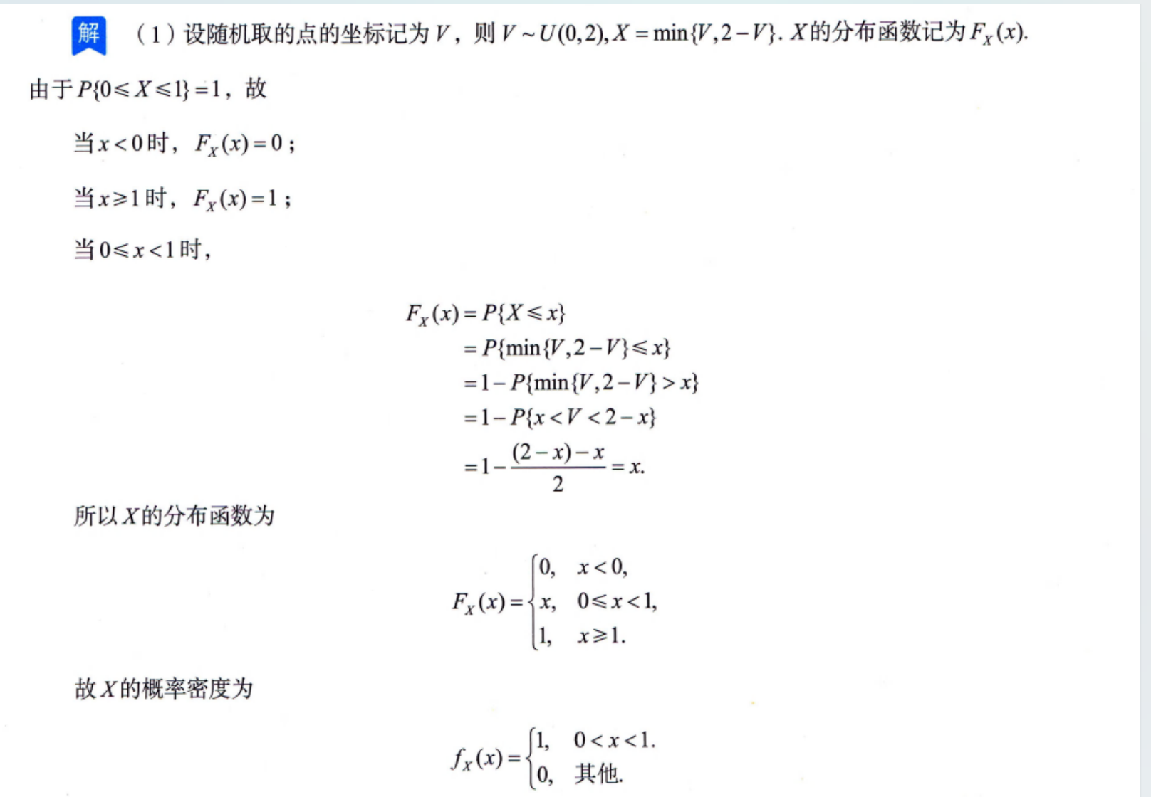
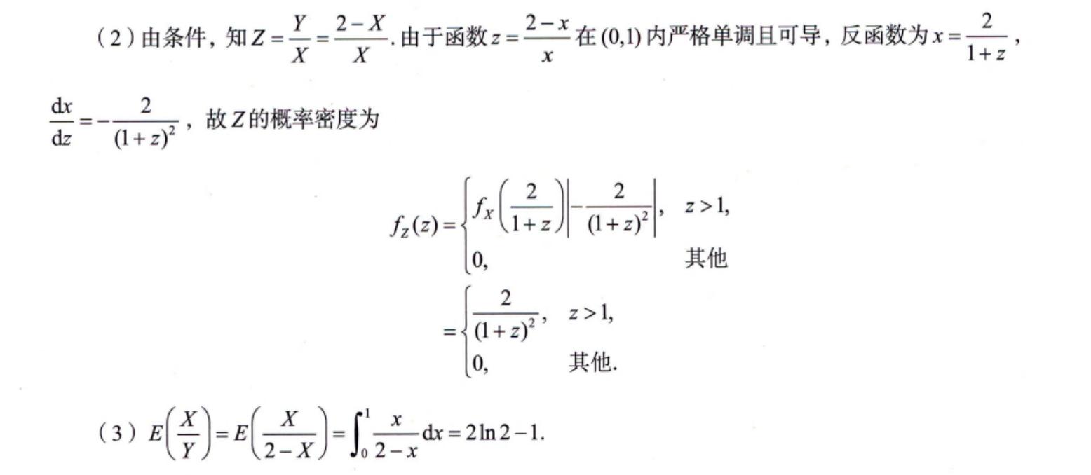
https://chatgpt.com/g/g-p-6a1d6c6f0a408191a175c887909fceb5-xian-dai-he-gai-lu-lun-ocr/c/6a7ee4ff-e37c-83ee-8722-c1d9c2f4ce70

|（注：部分内容可能由 AI 生成）

